**How to log in and access remote applications from home**

**-install/use the Citrix Remote Connection-**

1. Go to: <https://myapps.uwinnipeg.ca>

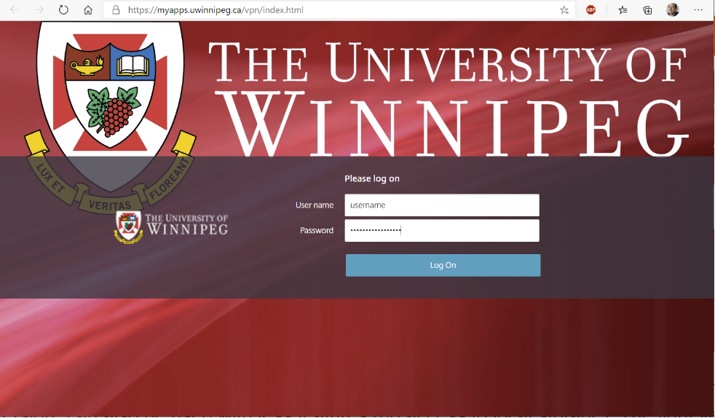

1. Log into the Citrix Remote Connection with your network login account and press “Log On”
2. For best results, select “Detect Receiver” this will install the CitrixWorkspaceApp.exe program. The “Use Light Version” can also be used with less features (no access to local storage). The light version is only recommended where the Workspace app cannot be installed.

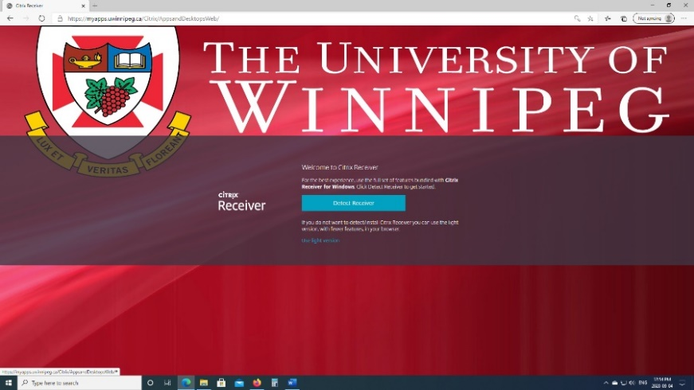

1. Select “I Agree with the Citrix license agreement” and press the Download button

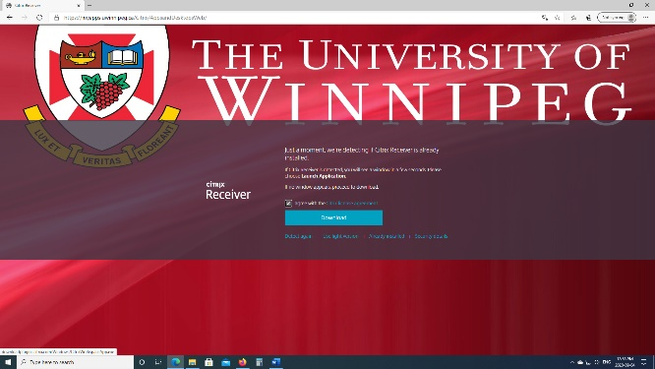

1. 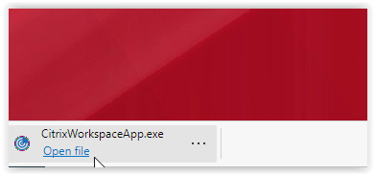Download the CitrixWorkspaceApp.exe and open file to install
2. Select Start on the “Welcome to Citrix Workspace” box

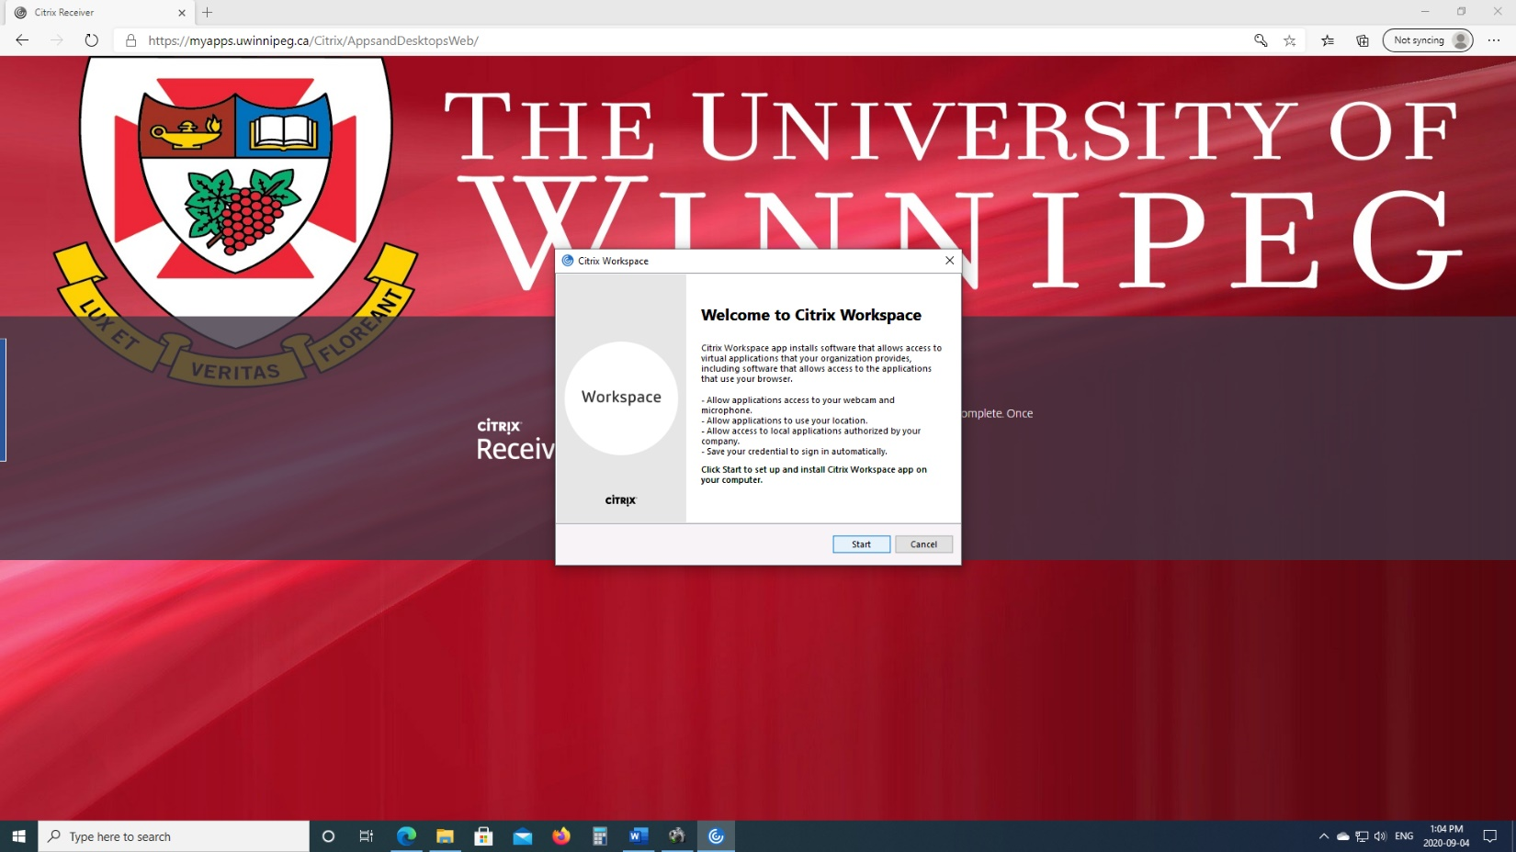

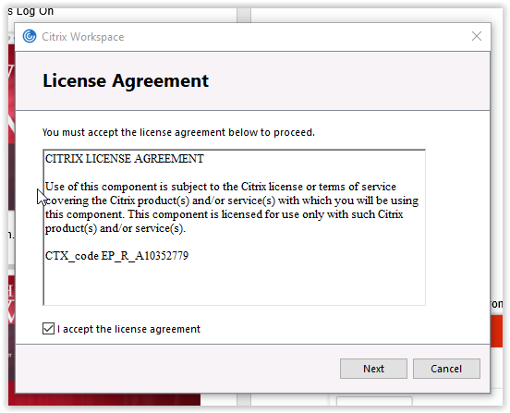

1. Select “I accept the license agreement” and press Next

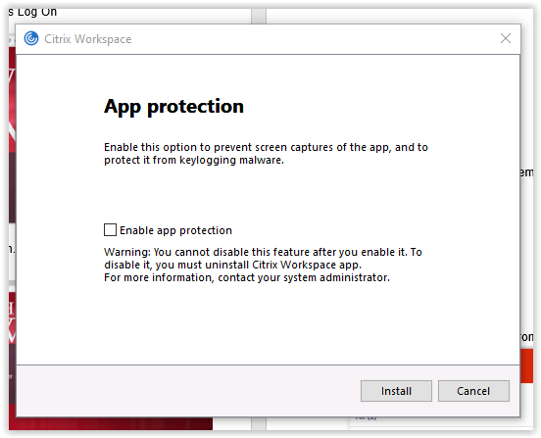

1. Do not select “Enable App Protection”, Press Install

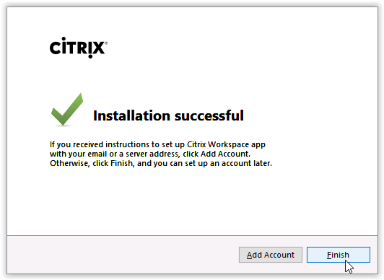

1. Do not press “Add Account”, Press Finish
2. Now go back to the main screen and press “Continue”



1. You should now see a screen with applications associated with courses that you are enrolled in (example below). Select one of the applications to launch it.

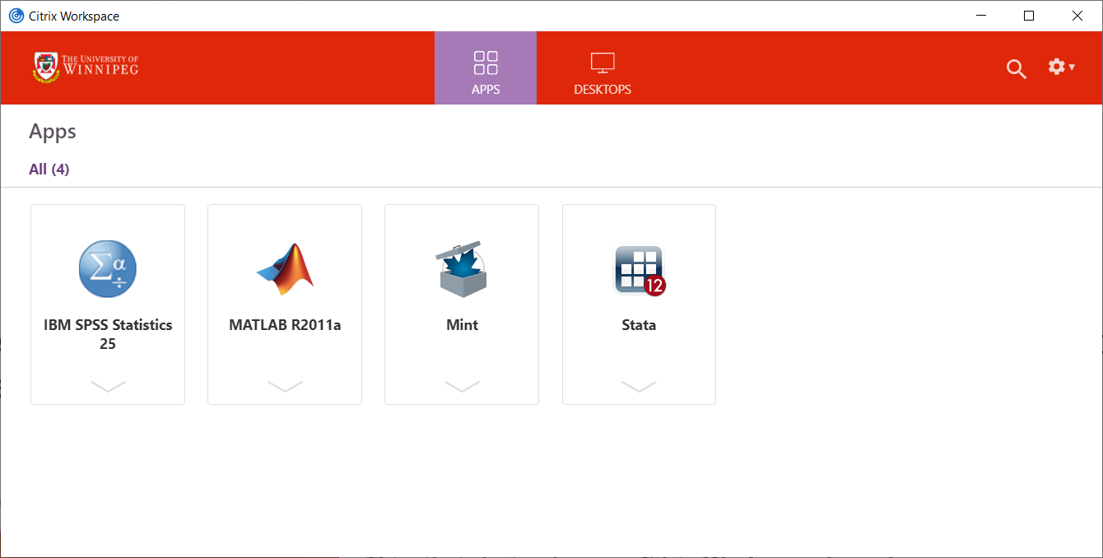

1. From within the application, when you select File -> Open and then select This PC, you will get a security prompt to access your local files. Press The bottom option “Read/write access”. This will allow you to access files both from your local computer and the files in your network file share.

